External Phone Number Mask Check

# Overview

Tool to check the external phone number mask on the primary line of phones (tkclass=1) & device profiles (tkclass=254). Incorrect masks can then optionally be fixed via import from a CSV files.

It shares dial plan configuration in *dialplan.json* with the Dial Plan Analyser tool.

Requires Python 3 to run, many Linux distros have Python installed by default. For Windows the easiest install is the official Python Windows version, or Miniconda works fine too:

Miniconda distribution of Python: <https://conda.io/miniconda.html>

Official Python distribution: <https://www.python.org/downloads/>

The lxml, Requests, urllib3 and Zeep libraries are required to work.

# Version History

Written by Chris Perkins in 2019:

v1.0 – initial release.

All testing was done using Windows with CUCM v11.5.

# Using the Tool

It connects to CUCM via the AXL API, so the AXL schema for the version of CUCM in use is required, this is downloaded from CUCM via **Application > Plugins > Cisco AXL Toolkit**. The required files contained within the .zip file are *AXLAPI.wsdl, AXLEnums.xsd* and *AXLSoap.xsd*.

Different CUCM servers are defined in JSON formatted files, allowing for multiple CUCM clusters running different versions (and thus different AXL schemas). Load the CSV file via **File > Load AXL**:

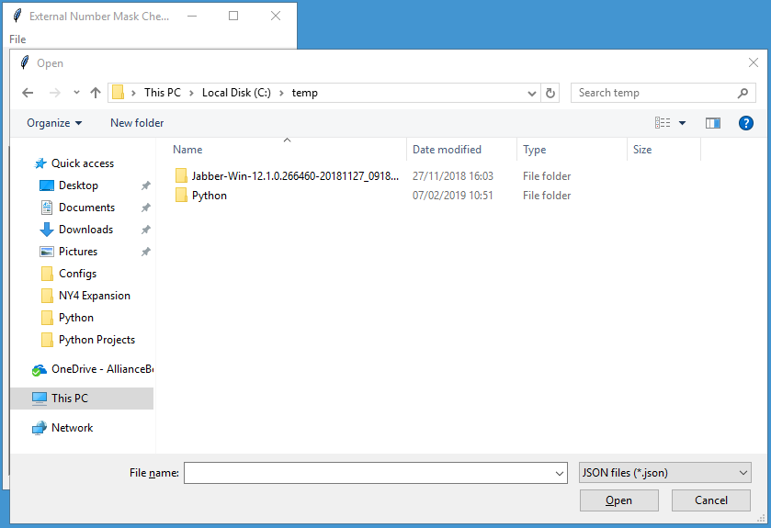

It will then prompt for the password:

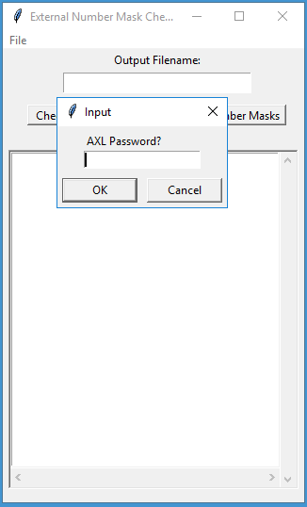

If you wish to save the output in a CSV file, enter the filename into the text box:

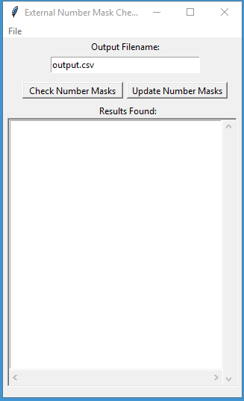

Click **Check Number Masks**, the results will be displayed & optionally saved.

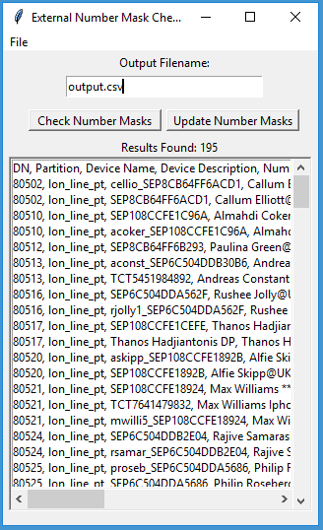

To fix external phone number masks, first review the outputted CSV file. Remove any rows that should be left alone & optionally adjust the New Number Mask if desired, then save it.

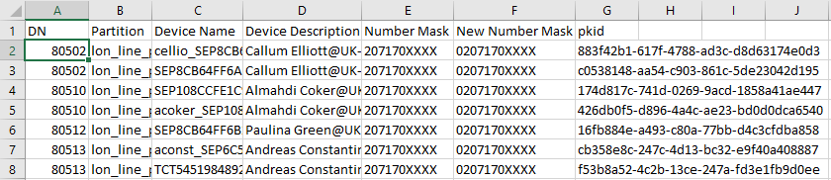

If you wish to save the failed updates to a CSV file, enter the filename into the text box. Then click **Update Number Masks**, it will prompt for the CSV file of updates to make. Any failed updates will be displayed & optionally saved.

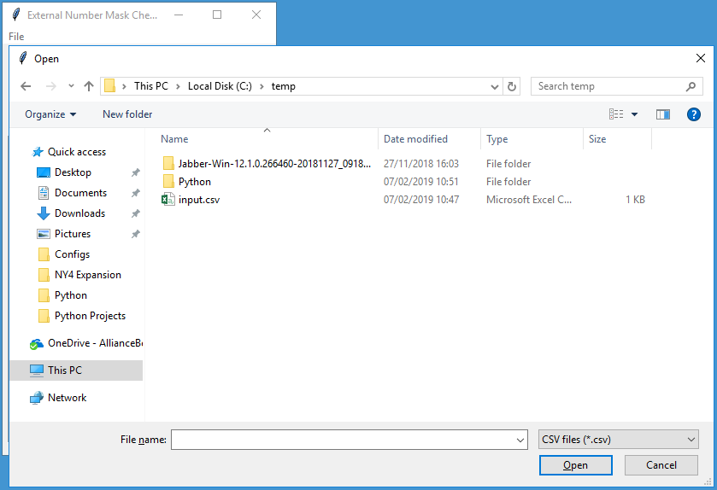

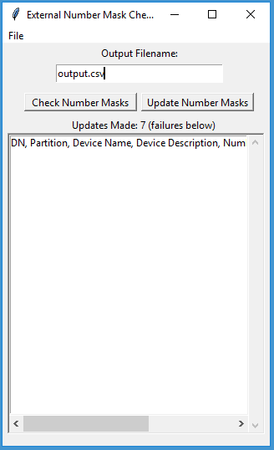

# Customising the Tool

The direct dial ranges to search for can be customised, so that the tool can be used for any CUCM cluster. These settings are stored in *dialplan.json* (shared with the Dial Plan Analyser) in JSON format, for example:

[

{

"range_start": "87300",

"range_end": "87399",

"partition": "lon_line_pt",

"mask": "0203100XXXX",

"description": "London 020310073XX"

}

]

* The JSON file starts with [ and ends with ].
* Each direct dial range is enclosed within { } and contains parameters for the description, range start, range end, mask and partition. The field headings and values must be enclosed within “”.
* The range end must be greater than the range start.
* The direct dial ranges must have a comma after each, except for the last one.

So to add another range to the above example:

[

{

"range_start": "87300",

"range_end": "87399",

"partition": "lon_line_pt",

"mask": "0203100XXXX",

"description": "London 020310073XX"

},

{

"range_start": "80501",

"range_end": "80700",

"partition": "lon_line_pt",

"mask": "0207170XXXX",

"description": "London 02071700[5-7]XX"

}

]

The parameters for using AXL are also stored in JSON format:

[

{

"fqdn": "cucm-emea-pub.somewhere.com",

"username": "AppAdmin",

"wsdl_file": "file://C://temp//AXLAPI.wsdl"

}

]

* “fqdn” should be the FQDN or IP address of the target CUCM publisher.
* “username” is an application or end user with the Standard AXL API Access role.
* “wsdl_file” points to the location of the AXL schema, note the slightly different path syntax for Windows.